Poornaprajna Post Doctoral Fellow Certificate (PPDFC) Programme
Student List
Sl No. | Registration No | Student Name & Address | Research Area | Title of the Proposed Research
1 | PIM101
  Dr. Purushottam Subedi
  Mulpani,Godawari-01, Lalitpur, Nepal
  Email id:purusubedi6@gmail.com
  Account and Finance
  Exploring the Serial Mediating Mechanisms of Cloud Accounting Adoption on Accounting Efficiency
2 | PIM102
  Dr. Suman Kamal Parajuli
  Budhanilkantha Nagarpalika-6, Kathmandu, Nepal
  Email id: sumankparajuli934@gmail.com
  Management
  Triad of Modern Work: Exploring The Role of Work-Life Integration, Balance, and Harmony on Employee Performance in Nepal’s Banking Sector
3 | PIM103 |  | Management -Emotional Intelligence | A Study on Emotional Intelligence and Academic Performance among Management Students
  Dr. Abhishek Venkteshwar
  No.11 Rhenius Street,
  Richmond Town,
  BANGALORE- 560025
  Email id:abhishekv1991@gmail.com
  Contact No.9980966677
4 | PIM104 | Dr. Kiran L Maney  No.3, 2nd Main Road  Seshadripuram  Bangalore-560020  Email id:kiranlmaney@gmail.com  Contact No.9980081985 | Marketing | Digital Marketing Adoption among Rural Women Entrepreneurs and its Impact on Household Decision-Making Dynamics in India | 
5 | PIM105 | Dr. N Bhargava  #95, 1st Floor, Ngef Layout, 10th Cross  Nagarbhava 2nd Main, Bangalore -560072  Email id:neellabhargava@gmail.com | Consumer Behavior, Online Shopping In Marketing | The Role of Artificial Intelligence In Shaping Consumer Behavior: A Study Of Hyper-Personalized Digital Commerce | 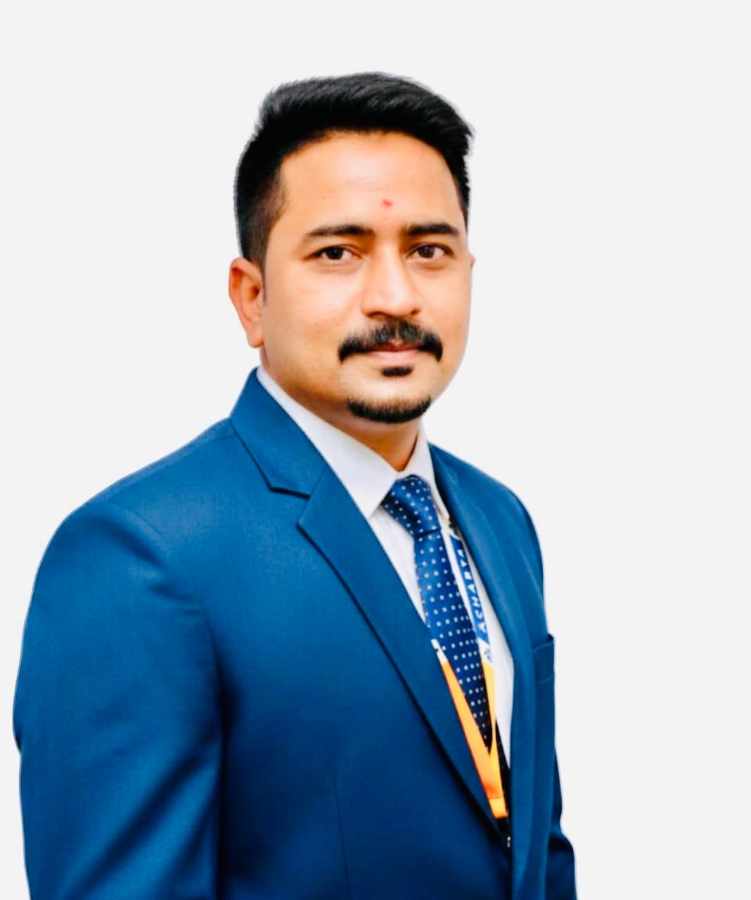
6 | PIM106 | Col Prof. Dr. Jyotirmaya Satpathy  A-22, HIG-1  Lingaraj Vihar, Bhubaneswar  Odisha – 751020  Email id:jyotisatpathy@gmail.com | Neuro- Management | Cerebral Correlates of Entrepreneurial Peak- Performance | 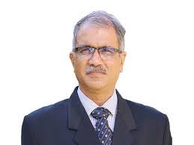
7 | PIM107 | Dr. S. Sandhya  42, 1st Main, 1st A Cross, Babanagar,  Opp Brindavan College of Engineering  Bagalur Cross, Bangalore – 560063  Email id:drsandhya42@gmail.com | Neuro- Management | Cerebral Correlates of Entrepreneurial Peak- Performance | 
8 | PIM108 | Dr. Asha S  #9, 8th Main , 8th Cross, Malleswaram  BANGALORE-3  Email id:asha.shamasundar@gmail.com  Contact No.9886607493 | Human Resource Management | Hybrid Work Model And Its Influence On Employee Productivity, Engagement, And Work-Life Balance | 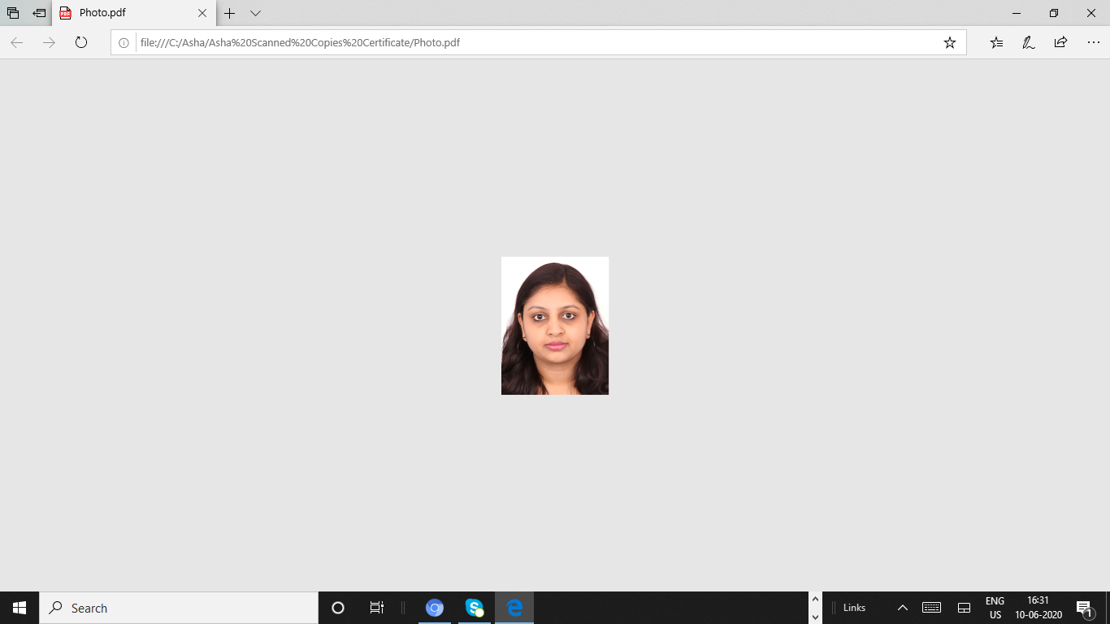
9 | PIM109 | Dr. Kesang Wangmo Bhutia  C/o Hotel Sodizang Retreat, Pelling  P/O Pelling  Near Pelling School Ground  District Gyalshing  West Sikkim, INDIA – 737113  Email id:kesang1319@gmail.com | Women In Technology and ICT | The Intersectionality of the Gender Digital Divide: A study of Sikkim, India

