 | NAME | ORGANISATION | SALARY PACKAGE
1 | ACHARYA SHREYA RAVINDRA | Visara partners Udupi | 3 lakhs P.a.
2 | ADARSH R ACHARYA | Self Employed | NA
3 | ADITHYA SAGRI | self employed | NA
4 | AISHWARYA | self employed | NA
5 | AISHWARYA J BHANDARY | Self Employed | NA
6 | AJAY KUMAR | Harsha Retail | 3 Lakhs p.a.
7 | AKASH HEGDE | Badagabettu Cooperative Society | 2.80 lakhs p.a.
8 | AKSHA HEGDE | On a look out | NA
9 | ALTHAF | On a look out | NA
10 | AMULYA P | Self Employed | NA
11 | ANUSHA | Self Employed | NA
12 | ANUSHA | Self Employed | NA
13 | ANUSHA SHET | Advith Itech Udupi | 3.25 lakhs p.a.
14 | ANUSHKUMAR | Self Employed | NA
15 | APEKSHA ISHWAR | K12 Techno service | 3.50 lakhs p.a.
16 | ASHRAY A | Self Employed | NA
17 | ASHWIN V RAO | Self Employed | NA
18 | ASHWINI | Manipal Technologies | 3 lakhs p.a.
19 | AVISHA | Self Employed | NA
20 | BHOOMIKA R SHETTY | Self Employed | NA
21 | CHAITHRA KUMARI | Self Employed | NA
22 | CHETANA RAMAKANT HEGDE | Self Employed | NA
23 | CHINMAY GANAPATHI HEGDE | Self Employed | NA
24 | DEEKSHITH | Self Employed | NA
25 | DEEKSHITH D KUMAR | Harsha Retail | 3 lakhs p.a.
26 | DEEKSHITHA | Edufy Tech Solutions | 4 lakhs p.a.
27 | DEEPA S | Harsha Retail | 3 lakhs p.a.
28 | DEEPAK POOJARY | Edufy Tech Solutions | 4 lakhs p.a.
29 | DEVIKA | Harsha Retail | 3 lakhs p.a.
30 | DHANUSHREE MADIVAL D | Harsha Retail | 3 lakhs p.a.
31 | DISHA P HEGDE | Edufy Tech Solutions | 4 lakhs p.a.
32 | DIVYA SHENOY | Edufy Tech Solutions | 4 lakhs p.a.
33 | G VAISHNAVI | Harsha Retail | 3 lakhs p.a.
34 | GANESH H BHAT | Self Employed | NA
35 | GANIGA SUDEEP D BHASKAR | Self Employed | NA
36 | GREESHMA SHETTY | Self Employed | NA
37 | GURUDARSHAN | Harsha Retail | 3 lakhs p.a.
38 | HARSHITH R.K. | Self Employed | NA
39 | HIMAL S KUMAR | Self Employed | NA
40 | JAYANTH J DAMBAL | Self Employed | NA
41 | JYOTHI RAMESHA METI | Self Employed | NA
42 | JYOTI SHREEKANTA HEGDE | Robosoft Technologies | 3.50 lakhs p.a.
43 | K AMBIKA | Self Employed | NA
44 | K C VIGNESH AITHAL | Self Employed | NA
45 | KARTHIK K | Self Employed | NA
46 | KEERTHANA U BHAT | Self Employed | NA
47 | KISHAN | Self Employed | NA
48 | KOWSHIKA | Self Employed | NA
49 | KRISHNAPRASAD SHENOY | Self Employed | NA
50 | KRUTHIKA K KANCHAN | Self Employed | NA
51 | LEELADHAR N KHARVI | K12 Techno service | 3.50 lakhs p.a.
52 | MEDHA PRABHU | Self Employed | NA
53 | NANDINI SHIVAKUMAR HEROOR | Self Employed | NA
54 | NISHMITH KUMAR | Self Employed | NA
55 | NISHMITHA SHETTIGAR | Self Employed | NA
56 | NITHIN S SHET | City Union Bank | 4 lakhs p.a.
57 | P ABHISHEK | Harsha Retail | 3 lakhs p.a.
58 | POOJA K.P. | Harsha Retail | 3 lakhs p.a.
59 | POOJARY SHIVANI VIJAY | Abharan Motors | 3 lakhs p.a.
60 | POORVIKA H S | Abharan Motors | 3 lakhs p.a.
61 | PRAJNA RAMAKRISHNA MOGER | Harsha Retail | 3 lakhs p.a.
62 | PRAJWAL | Harsha Retail | 3 lakhs p.a.
63 | PRATHEEKSHA | Harsha Retail | 3 lakhs p.a.
64 | PRATHEEKSHA | Harsha Retail | 3 lakhs p.a.
65 | PUNEETH | Q spiders | 3.5 lakhs p.a.
66 | PUNEETH CHANDRAKANTH POOJARY | Q spiders | 3.5 lakhs p.a.
67 | RACHANA | Q spiders | 3. 5 lakhs p.a.
68 | RAHUL | Harsha Retail | 3 lakhs p.a.
69 | RAHUL RAMACHANDRA NAIK | self employed | NA
70 | RAHUL T G | self employed | NA
71 | RIHAL AHMAD | self employed | NA
72 | ROOPA | K12 Techno service | 3.25 lakhs p.a.
73 | SAMEEKSHA S P | K12 Techno service | 3.25 lakhs p.a.
74 | SAMIKSHA S SHETTY | Harsha Retail | 3 lakhs p.a.
75 | SANNIDHI | self employed | NA
76 | SAVARI SHETTY | Harsha Retail | 3 lakhs p.a.
77 | SHAROON SHASHIDHAR SUVARNA
78 | SHREERAKSHA B | City Union Bank | 5 lakhs p.a.
79 | SHREYA | self employed | NA
80 | SHREYA | self employed | NA
81 | SHREYAS | self employed | NA
82 | SHRIKRISHNA | self employed | NA
83 | SHRILAXMI SANTHOSH NAIK | self employed | NA
84 | SHRINIDHI NARAYANA BHAT | self employed | NA
85 | SHRINIDHI S RAO | Harsha Retail | 3 lakhs p.a.
86 | SHRISHANTH | self employed | NA
87 | SPANDANA K M | self employed | NA
88 | SUCHITRA PAI B | self employed | NA
89 | SUJAN S KUMAR | Edufy Tech Solutions | 4 lakhs p.a.
90 | SUMA G P | Axis Bank | 4 lakhs p.a.
91 | SUMANTH | MAHE Manipal | 3.5 lakhs p.a.
92 | SURAKSHA DEVADIGA | self employed | NA
93 | SUSHANTH SALIYAN | self employed | NA
94 | SUSHMITHA S | self employed | NA
95 | SWAROOP S NAIK | self employed | NA
96 | SWATHI | self employed | NA
97 | TITIKSHA CHIDAMBAR BHAT | self employed | NA
98 | TULASI B MOGER | City Union Bank | 5 lakhs p.a.
99 | ULLAS K AMIN | Aster DM Health Care | 4 lakhs p.a.
100 | VAISHAKH HEBBAR | Farm Masters Bangalore | 4 Lakhs p.a.
101 | VIJAYALAXMI ANILKUMAR HIREMATH | Self Employed | NA
102 | VIKRAM J U | Self Employed | NA
103 | YOGESH S | Self Employed | NA
104 | DEEKSHA | Self Employed | NA
105 | PAVAN MARUTI CHALAWADI | Self Employed | NA
106 | BASAVALINGA | Self Employed | NA

Salary Package Distribution:
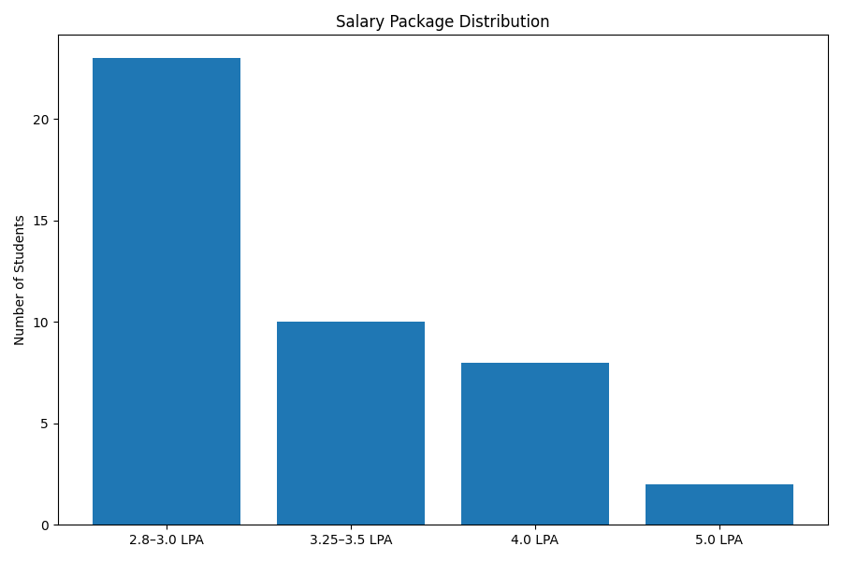
Detailed Placement Category Graph:
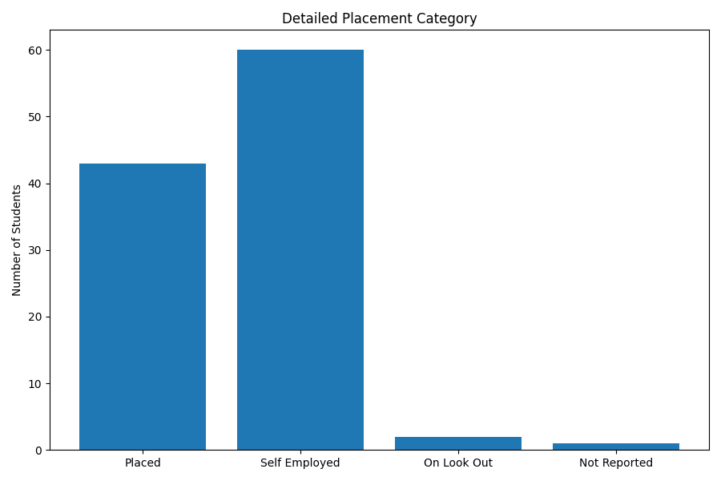
Recruiter-wise Placement Share:
