Poornaprajna Institute of Management
Udupi ‐ India
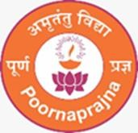
Micro Research Centre (MRC) Name of MRC:
Centre for Case Studies on Best Practices in the Human Resource Mnagement
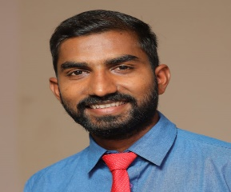
Name & Designation of the Coordinator:
Mr. Venkatesh Shetty, Assistant Profesor
Poornaprajna Institute of Management

- Purpose:
The purpose of the Centre for Case Studies on Best Practices in Human resource management is to systematically investigate, document, and disseminate best practices and exemplary models in human resource management to enhance the quality, effectiveness, and impact of the organisation globally.

- Objectives:
- To identify and analyze best practices and successful models in HRM and research across various organisations.
- To develop a comprehensive repository of case studies that highlight best practices and successful strategies in HRM.
- To provide evidence-based recommendations for improving HRM policies, practices, and research methodologies.

(iii) Description:
The research methodology for the Centre will be a mix of qualitative and quantitative approaches:
- Case Study Methodology: In-depth case studies will be conducted to explore best practices within selected organisations. This will involve site visits, interviews, surveys, and analysis of organisational documents.
- Comparative Analysis: Comparative studies will be performed to evaluate the effectiveness of different best practices across various contexts.
- Surveys and Questionnaires: Surveys will be distributed to gather quantitative data from a broad range of ornganisations to identify trends and common factors in successful innovations.
- Focus Groups: Focus groups will be organized with stakeholders, including HR, employees and best practices.
- Mixed Methods: Combining qualitative and quantitative data to provide a holistic understanding of the cases studied.

(iv) Proposed Functions:
- Conducting comprehensive research on innovative practices and best practices in HRM.
- Creating and maintaining a database of case studies that can be accessed by organisation, researchers, and policymakers.
- Organizing conferences, seminars, and workshops to disseminate findings and facilitate dialogue on innovations in HRM.
- Publishing research reports, articles, and books that highlight key findings and recommendations.

(v) Expected Outcomes:
A comprehensive collection of case studies that provide valuable insights into successful and best practices in HRM.
Enhanced understanding and awareness among organisation of effective strategies for improving workers quality and research outcomes.
Increased collaboration and knowledge exchange among HR, researchers, and policymakers, leading to the widespread adoption of best practices.
Evidence-based policy recommendations that can inform the development of HR policies at various organisational levels.

- List of the Team Members :
Mr. Venkatesh Shetty

Mr. Venkatesh Shetty
Date : 20/05/2025
Name & Signature of Coordinator with date.

