Poornaprajna Institute of Management
Udupi ‐ India

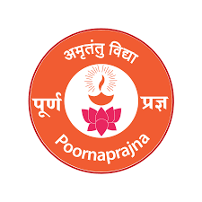
Micro Research Centre (MRC)
Name of MRC: Centre for Research on Public Issue Objectives

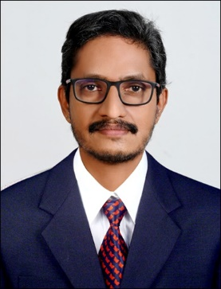

Dr. Naveen Kumar K R, Associate Professor
Poornaprajna Institute of Management

1. Purpose: To Analyse and Understand the ‘Going Public’ decisions of companies in India

2. Objective:
i) To study motives behind companies’ decisions to for public issues in general
ii) To analyse the reasons behind going for public issues by companies in India
iii) To study the concept of ‘Offer for Sale’ in public issues
iv) To study the concept of ‘Fresh Issues’ in public issues

3. Description on Proposed Research: To download the soft copies of the final offer documents of companies going public from the SEBI website. Analysing the ‘Issue Objectives’ section of these final offer documents. Also, accessing and analysing the contents from other related websites to get further insights on the going public decisions of companies in India.

4. Expected Outcome:
i) Understanding the reasons behind going public decisions of companies in India
ii) Understanding the ‘Offer for Sale’ decision by companies in public issues
iii) Understanding the ‘Fresh Issue’ decision by companies in public issues

5. List of the Team Members:
i) Dr. Naveen Kumar K R

6. List of Working Papers:
(1) A Study on ‘Going Public’ Decision of Companies in India

7. List of related Published Papers in Journals, Proceedings, Book Chapters, Magazines by Coordinator & his/her Group members year-wise in APA format.
- Hawaldar, I. T., Kumar K. R. N., & Mallikarjunappa, T. (2021), Pricing and Performance of Indian IPOs in the Free-Pricing Era: An Empirical Study, Journal of Legal, Ethical and Regulatory Issues, 24(6), 1-15
- Kumar, K. R. N., Hawaldar, I. T., & Mallikarjunappa, T. (2018), Windows of Opportunity and Seasoned Equity Offerings: An Empirical Study, Cogent Economics & Finance, 6(1), 1-18
- Hawaldar, I. T., Kumar, K. R. N., & Mallikarjunappa, T. (2018), Pricing and Performance of IPOs: Evidence from Indian Stock Market, Cogent Economics & Finance, 6(1), 1-20

Dr. Naveen Kumar K R 18-05-2024

